Project Requirement
You will be given a source database for an Online Travel Company: NYCTaxi
The Source database is to be given in the .SQL format.
The .SQL file has:
- Tables Creation Script
- Data Insertion Script
- Data Validations Script
- Relations Script
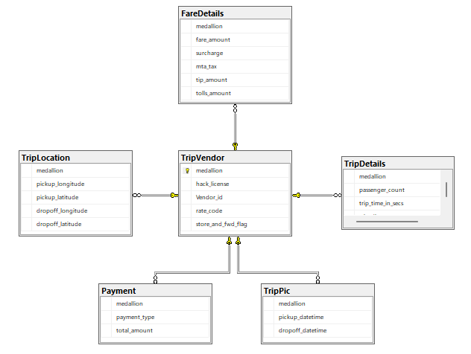

Phase 1 Requirement:
In your Local Computer (On-Prem):
You need to install (run .sql file for) the given source database script. Preferably in SQL Server 2025.
Understand the tables and their relations using Database Diagrams

Requirement 1: Identify the anomalies (Design Issues or Schema Defects).
Implement the possible solutions.
Ex: Wrong Data Type Selection
Ex: Wrong Primary Key Column
Ex: Wrong Foreign Key Column

Requirement 2: Prepare a Data Sheet with:
Schemas
Tables
Columns
Data Types

Submit your modified .sql script(s) + Data Sheet (excel format) at: www.sqlschool.com/submit

Phase 2: Aggregated Data Loads to Azure SQL Pool using ADF
Step 1: Analyze the source (OLTP) Tables and data, relations.
Plan all possible joins and aggregations. Generate TSQL Scripts.

Step 2: Create Dedicated SQL Pool (SQL DW) in a new Azure SQL Server (Logical Server)

Step 3: Create ADLS Storage Account with required containers to implement ETL Staging, Logging &
BLOB Data Store

Step 4: Design ADF Pipelines to implement aggregated Data Loads from On-Premises SQL DB (From
Phase 1 Solution) to Azure SQL Pool (Synapse). Install SHIR as needed.

Note: Ensure every pipeline you design is:
- Optimized
- Logged
- Staged

Step 5: Bring all pipelines from Step 4 into one Master Pipeline.
Optimize this Master Pipeline
Trigger this Pipeline with Proper Tumbling Window (Schedule, Retries..)

Step 6: You shall submit:
- .SQL Script for DWH Schema (Only Table Structures, no data) @ Aggregated Loads
- Pipelines you created above using GIT Repo Link

Phase 3: Incremental Data Loads to Azure SQL Pool using ADF
Step 1: For each table at the source, create a corresponding DWH table in Synapse to store historical &
incremental data.
Identify proper Business Key for each table at the source

Step 2: For each table at destination:
Create a pipeline, use Upsert Copy Method, perform Incremental Loads
Specify the Business Key.
Note: Ensure every pipeline you design is:
- Logged
- Staged
- Set proper DIU & DOCP
Step 3: Create a Master Pipeline:
Include all pipelines from step 2 above
Schedule & Trigger this Master Pipeline

Step 4: Configure GIT for Team Collaboration

Step 5: You shall submit:
- .SQL Script for DWH Schema (Only Table Structures, no data) @ Incremental Loads
- Pipelines you created above using GIT Repo Link

